Blooming  Wedding Form | Flair |  |  | 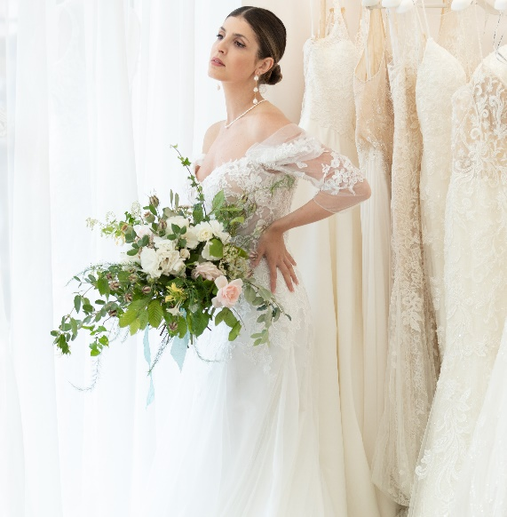

Client Details:

Names of the couple:
Email:
Contact number:

Wedding details:

Wedding date & time:
Ceremony location:
Reception location:
Ceremony start time, if known:
Reception start time, if known:
Desired colour palette:
How would you describe your dream wedding?
Pinterest Mood Board
(please share a link here)
Floral budget
(On average my couple spend on flowers between £2000 - £4000)

Thank you!
Maya
Blooming Flair
+48 7871550781
Email: hello@bloomingflair.co.uk
Website: www.bloomingflair.co.uk
Instagram: blooming_flair

